**CHILD LABOUR**

By

Donal. D. Gonsalves (132273)

A report submitted in partial fulfillment

of the requirement for

TE V SEM BCE course

Under the guidance of

Ms Ann John



**Department of Computer Engineering**

**St. Francis Institute Of Technology**

**Date: 09 October 2014**

**CHILD LABOUR**

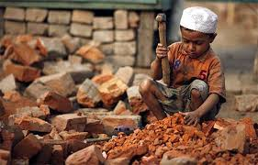

**ACKNOWLEDGEMENT**

We are grateful to our Principal and Director for providing us with best of infrastructure and resources to prepare this project. We thank them for the library & the internet access computers made available which has immensely helped us in our study of this report and its successful completion.

We also take this opportunity to express our gratitude towards our guide Ms. Ann John, for the constant encouragement, support and guidance in our endeavor without which we would have difficult to maintain my tempo and enthusiasm. Working with her has been wonderful learning experience.

We also thank college authorities and professors concerned, who have through meticulous planning, created an environment in college which helps to explore new developments and study thoroughly the given subject so as prepare a detailed & systematic report. I further extend my gratitude to the non-teaching staff and in particular the computer lab assistants & the library staff for their help which has been instrumental in completion of this report.

Ms. Ann John Donal Domnic Gonsalves

**TABLE OF CONTENTS**

|  |  |  |  |  |
| --- | --- | --- | --- | --- |
| **Topic** | | | | **Page No.** |
| 1. | INTRODUCTION | | | 7 |
| 2 | HISTORY | | | 8 |
|  | 2.1 | | INDUSTRIAL REVOLUTION | 8 |
|  | 2.2 | | VICTORIAN ERA | 8 |
|  | 2.3 | | EARLY 1990S | 9 |
|  | 2.4 | | HOUSEHOLD ENTERPRISES | 10 |
|  | 2.5 | | COLONIAL EMPIRES | 10 |
|  | 2.6 | | SOVIET UNION AND RUSSIA | 11 |
|  | 2.7 | | 21ST CENTURY | 11 |
| 3 | CAUSES OF CHILD LABOUR | | | 12 |
|  | 3.1 | | PRIMARY CAUSES | 12 |
|  | 3.2 | | CULTURAL CAUSES | 13 |
|  | 3.3 | | MACROECONOMIC CAUSES | 13 |
| 4 | CHILD LABOUR LAWS | | | 14 |
| 5 | CHILD LABOUR INCIDENT | | | 15 |
|  | 5.1 | COCA PRODUCTION | | 15 |
|  | 5.2 | MINING IN AFRICA | | 16 |
|  | 5.3 | MEAT PACKING | | 16 |
|  | 5.4 | SILK WEAVING | | 17 |
|  | 5.5 | GAP | | 17 |
| 6 | GRAPHICAL REPRESENTATION | | | 18 |
| 7 | ELIMINATION OF CHILD LABOUR | | | 21 |
|  | 7.1 | STRATEGIES FOR ELIMINATION OF CHILD LABOUR | | 22 |
| 8 | RECOMMANDATIONS | | | 24 |
| 9 | CONCLUSION | | | 25 |
| 10 | BIBLOGRAPHY AND REFERENCES | | | 26 |

**FIGURE OF CONTENTS**

|  |  |  |
| --- | --- | --- |
| **Topic** | | **Page No.** |
| 2.1 | INDUSTRIAL REVOLUTION | 8 |
| 2.2 | VICTORIAN ERA | 9 |
| 2.3 | EARLY 1990S | 9 |
| 2.4 | HOUSEHOLD ENTERPRISE | 10 |
| 3.1 | CYCLE OF POVERTY | 12 |
| 5.1 | COCOA PRODUCTION | 15 |
| 5.2 | MINING IN AFRICA | 16 |
| 6.1 | PERCENTAGE OF CHILD LABOUR | 18 |
| 6.2 | DISTRIBUTION OF CHILD LABOUR | 19 |
| 6.3 | DISTRIBUTION OF CHILD LABOUR | 20 |
| 7.1 | STATISTICS OF CHILD LABOUR | 23 |

**ABSTRACT**

Child labour is the practices of having children engage in economic activity, on part or full-time basis. The practice deprives children of their childhood, and is harmful to their physical and mental development. Poverty, lack of good schools and growth of informal economy are considered as the important causes of child labour.

Mahatma Gandhi says, “If we are to teach real peace in this world, and if we are to carry on a real war against war, we shall have to begin with the children." But due to an increase in child labour in India, the future of children seems to be in dark. And at the same time the nation bears the deadly consequences of this curse of the society.

Though India is signatory of various international Conventions and Agreements, there is growing number of child labour in India. They work under very hazardous conditions. Finally we conclude that the proposed solution may be found worthy in overcoming the challenges that have emerged due to the child labour.

The main objective of this project was to make awareness about child labour in India as well as around the globe and measures to lessen it to the possible extent. While working on this project I learned about the turmoil that young children undergo their deteriorating health and their hardships.

**1. INTRODUCTION**

Child labour refers to the employment of children in any work that deprives children of their childhood, interferes with their ability to attend regular school, and that is mentally, physically, socially or morally dangerous and harmful.

Children are the greatest gift to humanity and Childhood is an important and impressionable stage of human development as it holds the potential to the future development of any society.

The Child is generally considered to a person who is less than 14 years of age and less developed, immature and cannot understand the consequences of any work , and not aware of their rights.

The term “child labour “is generally used to refer “all children who are less than 15 years old and forced to work on regular basis to earn livelihood for themselves and their family in organization or non- organization and hazardous and non- hazardous condition that are exploitative and affective to their health and to their physical and mental development and deprived of education and training opportunities.

According to International Labour Organization( ILO,2002 ) “ all children under 15 years of age who are economically active excluding those who are under 5 years and those between12-14 years old who spend less than 14 hours in a week open.

The incidence of child labour in the world decreased from 25% to 10% between 1960 and 2003, according to the World Bank. Nevertheless, the total number of child labourers remains high, with UNICEF and ILO acknowledging an estimated 168 million children aged 5–17 worldwide, were involved in child labour in 2013.

Child labour restricts the right of children to access and benefit from education and denies the fundamental opportunity to attend school. Child labour, thus, prejudices children’s education and adversely affects their health and safety.

**2. HISTORY**

**2.1. INDUSTRIAL REVOLUTION**

During the Industrial Revolution, children as young as four were employed in production factories with dangerous, and often fatal, working conditions. Based on this understanding of the use of children as labourers, it is now considered by wealthy countries to be a human rights violation, and is outlawed, while some poorer countries may allow or tolerate child labour. Child labour can also be defined as the full-time employment of children who are under a minimum legal age.

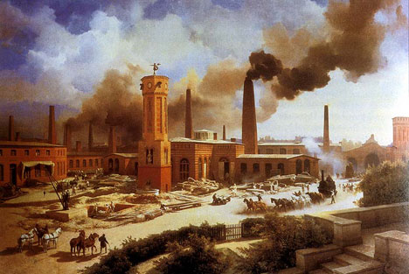

Fig.2.1.INDUSTRIAL REVOLUTION

**2.2. VICTORIAN ERA**

The Victorian era became notorious for employing young children in factories and mines and as chimney sweeps. Child labour played an important role in the Industrial Revolution from its outset, often brought about by economic hardship. Charles Dickens for example worked at the age of 12 in a blacking factory, with his family in debtor’s prison. The children of the poor were expected to help towards the family budget, often working long hours in dangerous jobs for low pay, earning 10–20% of an adult male’s wage. In England and Scotland in 1788, two-thirds of the workers in 143 water-powered cotton mills were described as children. In 19th-century Great Britain, one-third of poor families were without a breadwinner, as a result of death or abandonment, obliging many children to work from a young age.

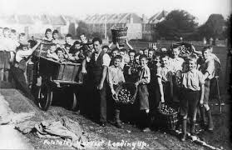

FIG.2.2. VICTORIAN ERA

**2.3. EARLY 1990S**

In the early 1900s, thousands of boys were employed in glass making industries. Glass making was a dangerous and tough job especially without the current technologies. The process of making glass includes intense heat to melt glass (3133 °F). When the boys are at work, they are exposed to this heat. This could cause eye trouble, lung ailments, heat exhaustion, cut, and burns. Since workers were paid by the piece, they had to work productively for hours without a break. Since furnaces had to be constantly burning, there were night shifts from 5:00 pm to 3:00 am many factory owners preferred boys under 16 years of age.

In 1910, over 2 million children in the same age group were employed in the United States. This included children who rolled cigarettes.

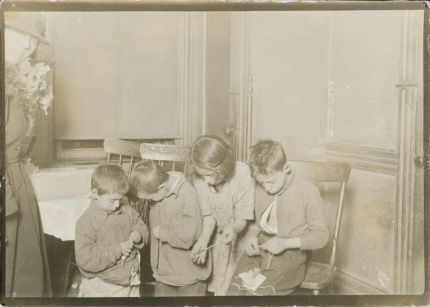

FIG.2.3. EARLY 1990S

**2.4. HOUSEHOLD ENTERPRISES**

Factories and mines were not the only place where child labour was prevalent in the early 20th century. Home-based manufacturing across the United States and Europe employed children as well. Governments and reformers argued that labour in factories must be regulated and the state had an obligation to provide welfare for poor. Legislation that followed had the effect of moving work out of factories into urban homes. Families and women in particular preferred it because it allowed them to generate income while taking care of household duties.

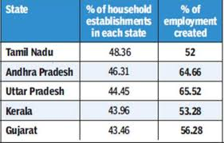

FIG.2.4.HOUSEHOLD ENTERPRISE

**2.5. COLONIAL EMPIRES**

Systematic use of child labour was common place in the colonies of European powers between 1650 to 1950. Millions of children worked in colonial agricultural plantations, mines and domestic service industries. Sophisticated schemes were promulgated where children in these colonies between the ages of 5–14 were hired as apprentice without pay in exchange for learning a craft. A system of Pauper Apprenticeship came into practice in the 19th century where the colonial master neither needed the native parents' nor child's approval to assign a child to labour, away from parents, at a distant farm owned by a different colonial master. Other schemes included 'earn-and-learn' programs where children would work and thereby learn.

**2.6. SOVIET UNION AND RUSSIA**

Although formally banned since 1922, child labour was widespread in the Soviet Union, mostly in the form of mandatory, unpaid work by schoolchildren on Saturdays and holidays. The students were used as a cheap, unqualified workforce on kolhoz (collective farms) as well as in industry and forestry. The practice was formally called "work education".

From the 1950s on, the students were also used for unpaid work at schools, where they cleaned and performed repairs. This practice has continued in the Russian Federation, where up to 21 days of the summer holidays is sometimes set aside for school works. By law, this is only allowed as part of specialized occupational training and with the students' and parents' permission, but those provisions are widely ignored.

**2.7. 21ST CENTURY**

Child labour is still common in many parts of the world. Estimates for child labour vary. It ranges between 250 to 304 million; if children aged 5–17 involved in any economic activity are counted. If light occasional work is excluded, ILO estimates there were 153 million child labourers aged 5–14 worldwide in 2008. This is about 20 million less than ILO estimate for child labourers in 2004. Some 60 percent of the child labour was involved in agricultural activities such as farming, dairy, fisheries and forestry. Another 25 percent of child labourers were in service activities such as retail, hawking goods, restaurants, load and transfer of goods, storage, picking and recycling trash, polishing shoes, domestic help, and other services. The remaining 15 percent laboured in assembly and manufacturing in informal economy, home-based enterprises, factories, mines, packaging salt, operating machinery, and such operations. Child labour predominantly occurs in the rural areas (70%) and informal urban sector (26%).

**3. CAUSES OF CHILD LABOUR**

**3.1. PRIMARY CAUSES**

International Labour Organization (ILO) suggests poverty is the greatest single cause behind child labour. For impoverished households, income from a child’s work is usually crucial for his or her own survival or for that of the household. Income from working children, even if small, may be between 25 to 40% of this household income. Other scholars such as Harsch on African child labour, and Edmonds and Pavcnik on global child labour have reached the same conclusion. Lack of meaningful alternatives, such as affordable schools and quality education, according to ILO, is another major factor driving children to harmful labour. Children work because they have nothing better to do. Many communities, particularly rural areas where between 60–70% of child labour is prevalent, do not possess adequate school facilities. Even when schools are sometimes available, they are too far away, difficult to reach, unaffordable or the quality of education is so poor that parents wonder if going to school is really worth it.

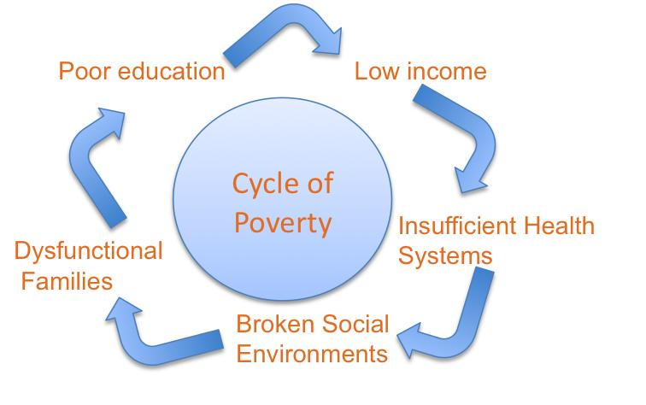

FIG.3.1. CYCLE OF POVERTY

**3.2. CULTURAL CAUSES**

In European history when child labour was common, as well as in contemporary child labour of modern world, certain cultural beliefs have nationalized child labour and thereby encouraged it. Some view that work is good for the character-building and skill development of children. In many cultures, particular where informal economy and small household businesses thrive, the cultural tradition is that children follow in their parents’ footsteps; child labour then is a means to learn and practice that trade from a very early age. Similarly, in many cultures the education of girls is less valued or girls are simply not expected to need formal schooling, and these girls pushed into child labour such as providing domestic services.

**3.3. MACROECONOMIC CAUSES**

Biggeri and Mehrotra have studied the macroeconomic factors that encourage child labour. They focus their study on five Asian nations including India, Pakistan, Indonesia, Thailand and Philippines. They suggest that child labour is a serious problem in all five, but it is not a new problem. Macroeconomic causes encouraged widespread child labour across the world, over most of human history. They suggest that the causes for child labour include both the demand and the supply side. While poverty and unavailability of good schools explain the child labour supply side, they suggest that the growth of low paying informal economy rather than higher paying formal economy is amongst the causes of the demand side. Other scholars too suggest that inflexible labour market, size of informal economy, inability of industries to scale up and lack of modern manufacturing technologies are major macroeconomic factors affecting demand and acceptability of child labour.

**4. CHILD LABOUR LAWS**

* Almost every country in the world has laws relating to and aimed at preventing child labour. International Labour Organization has helped set international law, which most countries have signed on and ratified.
* According to ILO minimum age convention (C138) of 1973, child labour refers to any work performed by children under the age of 12, non-light work done by children aged 12–14, and hazardous work done by children aged 15–17. Light work was defined, under this Convention, as any work that does not harm a child’s health and development, and that does not interfere with his or her attendance at school. This convention has been ratified by 135 countries.
* The United Nations adopted the Convention on the Rights of the Child in 1990, which was subsequently ratified by 193 countries. Article 32 of the convention addressed child labour, as follows:
  + …Parties recognize the right of the child to be protected from economic exploitation and from performing any work that is likely to be hazardous or to interfere with the child’s education, or to be harmful to the child’s health or physical, mental, spiritual, moral or social development.
* Under Article 1 of the 1990 Convention, a child is defined as “… every human being below the age of eighteen years unless, under the law applicable to the child, majority is attained earlier.” Article 28 of this Convention requires States to, “make primary education compulsory and available free to all.”
* Three countries that have not ratified the 1990 Convention are Somalia, South Sudan and the United States.
* In 1999, ILO helped lead the Worst Forms Convention 182 (C182), which has so far been signed upon and domestically ratified by 151 countries including the United States. This international law prohibits worst forms of child labour, defined as all forms of slavery and slavery-like practices, such as child trafficking, debt bondage, and forced labour, including forced recruitment of children into armed conflict.

**5. CHILD LABOUR INCIDENTS**

**5.1. COCOA PRODUCTION**

In 1998, UNICEF reported that Ivory Coast farmers used enslaved children – many from surrounding countries. In late 2000 a BBC documentary reported the use of enslaved children in the production of cocoa, the main ingredient in chocolate in West Africa. Other media followed by reporting widespread child slavery and child trafficking in the production of cocoa. In 2001, the US State Department estimated there were 15,000 child slaves’ cocoa, cotton and coffee farms in the Ivory Coast, and the Chocolate Manufacturers Association acknowledged that child slavery is used in the cocoa harvest.

Malian migrants have long worked on cocoa farms in the Ivory Coast, but in 2000 cocoa prices had dropped to a 10-year low and some farmers stopped paying their employees. The Malian counsel had to rescue some boys who had not been paid for five years and who were beaten if they tried to run away. Malian officials believed that 15,000 children, some as young as 11 years old, were working in the Ivory Coast in 2001. These children were often from poor families or the slums and were sold to work in other countries. Parents were told the children would find work and send money home, but once the children left home, they often worked in conditions resembling slavery. In other cases, children begging for food were lured from bus stations and sold as slaves. In 2002, the Ivory Coast had 12,000 children with no relatives nearby, which suggested they were trafficked, likely from neighboring Mali, Burkina Faso and Togo.

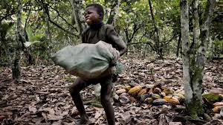

FIG. 5.1. COCOA PRODUCTION

**5.2. MINING IN AFRICA**

In 2008, Bloomberg claimed child labour in copper and cobalt mines that supplied Chinese companies in Congo. The children are creuseurs, that is they dig the ore by hand, carry sacks of ores on their backs, and these are then purchased by these companies. An African NGO report claimed 80,000 child labourers under the age of 15, or about 40% of all miners, were supplying ore to Chinese companies in this African region.

In West Africa, in countries such as Mali - the third largest exporter of gold in Africa - between 20,000 and 40,000 children work in artisanal mining. Locally known as orpaillage, children as young as 6 years old work with their families. These children and families suffer chronic exposure to toxic chemicals including mercury, and do hazardous work such as digging shafts and working underground, pulling up, carrying and crushing the ore. The poor work practices harm the long term health of children, as well as release hundreds of tons of mercury every year into local rivers, ground water and lakes.

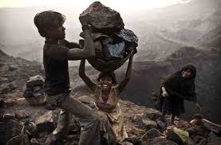

**Fig.5.2.MINING IN AFRICA**

**5.3. MEATPACKING**

In early August 2008, Iowa Labour Commissioner David Neil announced that his department had found that Agriprocessors, a kosher meatpacking company in Postville which had recently been raided by Immigration and Customs Enforcement, had employed 57 minors, some as young as 14, in violation of state law prohibiting anyone under 18 from working in a meatpacking plant. Neil announced that he was turning the case over to the state Attorney General for prosecution, claiming that his department's inquiry had discovered "egregious violations of virtually every aspect of Iowa's child labour laws."

**5.4. SILK WEAVING**

A 2003 Human Rights Watch report claimed children as young as five years old were employed and worked for up to 12 hours a day and six to seven days a week in silk industry. These children, claimed HRW, were bonded child labour in India, easy to find in Karnataka, Uttar Pradesh and Tamil Nadu.

In 2010, a German news investigative report claimed that in silk weaving industry, non-governmental organizations (NGOs) had found up to 10,000 children working in the 1,000 silk factories in 1998. In other places, thousands of bonded child labours were present in 1994. After UNICEF and NGOs got involved, after 2005, child labour figure is drastically lower, with the total estimated to be fewer than a thousand child labourers.

**5.5. GAP**

A 2007 report claimed some GAP products had been produced by child labourers. GAP acknowledged the problem and announced it is pulling the products from its shelf. The report found Gap had rigorous social audit systems since 2004 to eliminate child labour in its supply chain. However, the report concluded that the system was being abused by unscrupulous subcontractors.

GAP's policy, the report claimed, is that if it discovers child labour was used by its supplier in its branded clothes, the contractor must remove the child from the workplace, provide it with access to schooling and a wage, and guarantee the opportunity of work on reaching a legal working age.

**6. GRAPHICAL REPRESENTATION**

**6.1. PERCENTAGE OF CHILD LABOUR**

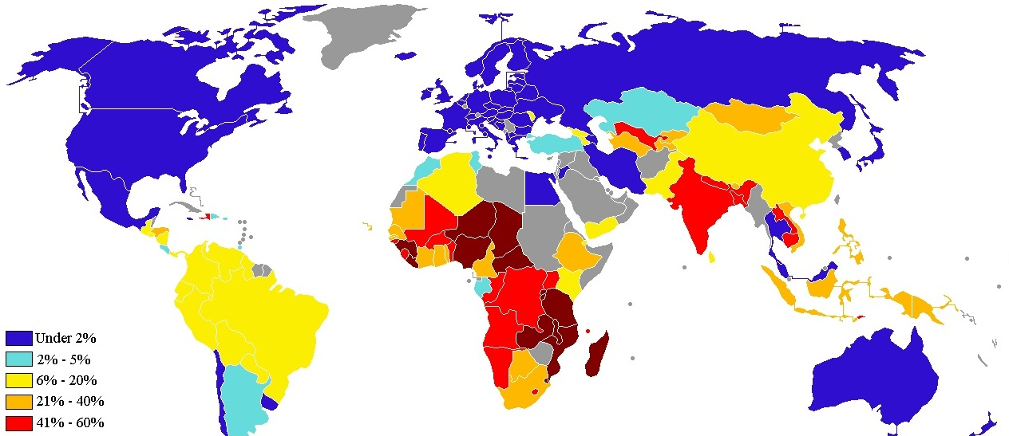

**6.2 .DISTRIBUTION OF CHILD LABOUR**

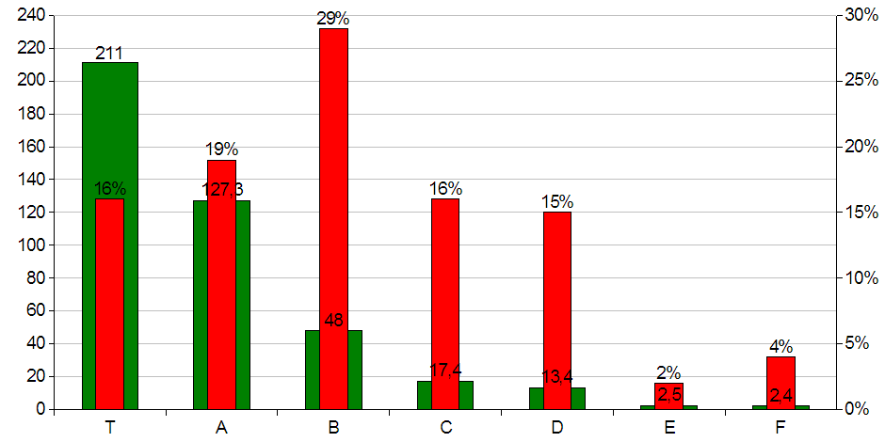

**6.3. DISTRIBUTION OF CHILD LABOUR**

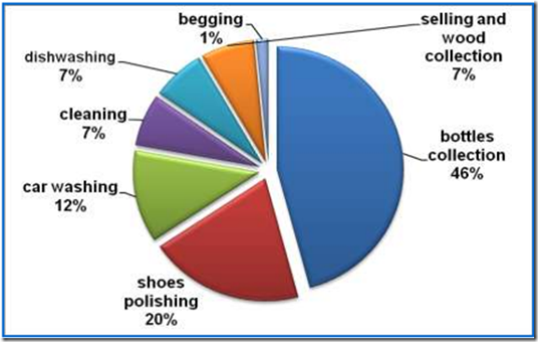

## 7. ELIMINATION OF CHILD LABOUR

The concern for children and the elimination of child labour in India continues to be an area of great concern and article of faith and commitment for successive governments. The Common Minimum Programme of the present government also speaks about the concern of the Government towards the problem of child labour. It states that the Government will strive for the elimination of child labour.

Child labour is a complex socio-economic problem to be dealt through sustained efforts over a period of time. While there could be many reasons for children not being able to complete even their primary education or the vocational training programmes, studies have revealed that it is poverty of the families, extent of social backwardness and an unsuitable curriculum which have contributed to the children either not going to school or dropping out of school even before they complete their compulsory education.

The International Programme on the Elimination of Child Labour (IPEC), founded in 1992, aims to eliminate child labour. It operates in 88 countries and is the largest program of its kind in the world. IPEC works with international and government agencies, NGOs, the media, and children and their families to end child labour and provide children with education and assistance.

As per the provisional figures of Census 2001, there are 12.5 million working children in age group of 5-14 years as compared to the child population of 252 million.

The policy of the Government is to ban employment of children below the age of 14 years in factories, mines and hazardous employment and to regulate the working conditions of children in other employments.

# 7.1. STRATEGIES FOR ELIMINATION OF CHILD LABOUR

# Motivating a broad alliance of partners to acknowledge and act against child labour.

# Carrying out a situational analysis to find out about child labour problems in a country.

# Assisting with developing and implementing national policies on child labour problems.

# Strengthening existing organizations and setting up institutional mechanisms.

# Creating awareness on the problem nationwide, in communities and workplaces.

# Promoting the development and application of protective legislation.

# Supporting direct action with (potential) child workers for demonstration purposes, including Time-bound Programmes to address Worst Forms of Child Labour.

# Replicating and expanding successful projects into the programmes of partners.

# Mainstreaming child labour issues into socio-economic policies, programmes and budgets.

FIG.7.1. STATISTICS OF CHILD LABOUR

|  |  |  |  |  |
| --- | --- | --- | --- | --- |
| Distribution of children | 2001 population census | 2006 population, projection and estimates | % of children to population | |
|  |  |  | 2001 | 2006 |
| Population |  |  |  |  |
| Male | 132367710 | 125485000 |  |  |
| Female | 120795938 | 116274000 |  |  |
| Total | 253163648 | 241759000 |  |  |
|  |  |  |  |  |
| Child Labour  (10-14) |  |  |  |  |
| Male | 6504336 | 4276744 | 8.8 | 6.7 |
| Female | 5862041 | 3894131 | 8.5 | 6.3 |
| Total | 12666377 | 8082954 | 8.7 | 6.5 |
|  |  |  |  |  |

**8. RECOMMENDATIONS**

* A majority of countries have adopted legislation to prohibit or place severe restrictions on the employment and work of children, much of it stimulated and guided by standards adopted by the International Labour Organization (ILO).
* The basis of determined and concerted action must be legislation, which sets the total elimination of child labour as the ultimate goal of policy, and puts measures into place for this purpose, and which explicitly identifies and prohibits the worst forms of child labour to be eliminated as a matter of priority.
* One of the most effective methods of ensuring that children do not start working too young is to set the age at which children can legally be employed or otherwise work.
* Priority should be given to put an immediate end to the most intolerable forms of child labour – slavery and slave-like practices, forced or compulsory labour, including debt-bondage and serfdom, the use of children in prostitution, pornography and the drug trade, and their employment in any type of work that is likely to jeopardise their health, safety, or morals.
* Education has an important role in both the promotion and the prevention of child labour. Inaccessible or inappropriate education may push children into the workplace prematurely.
* Trade unions, the media and non-governmental organizations have an important function in identifying and bringing to the public’s attention problems of child exploitation. In this way political will for action can be strengthened.

**9. CONCLUSION**

There is a lot of provision added in the constitution of India for child welfare to overcome child labour and to avoid the situations that comes as a consequence of the child labour. At an International level, different organizations are also working for the same cause. But still there are a lot of efforts needed to create an environment which is free from child abuse.

Child rights need to be actively respected rather than simply acknowledged, and we must admit that more than the passage of laws and publicizing the same to stimulate the kind of debate in such a way that leads to attitudinal change.

The problem of child labour can be best addressed by adopting various strategies ranging from enrollment and retaining children in the school, income generation avenues for adults, poverty eradication programs simultaneously. Awareness generation in the society towards universalization of primary education.

Government has accordingly been taking proactive steps to tackle this problem through strict enforcement of legislative provisions along with simultaneous rehabilitative measures. State Governments, which are the appropriate implementing authorities, have been conducting regular inspections and raids to detect cases of violations. Since poverty is the root cause of this problem, and enforcement alone cannot help solve it, Government has been laying a lot of emphasis on the rehabilitation of these children and on improving the economic conditions of their families.

**10. BIBLIOGRAPHY & REFERENCES**

1. Ali, N. (1987), ‘Child Labour in the Carpet Industry of Kashmir’, in Gupta and Voll.
2. Govt. of India (1933), The Children (Pledging of Labour) Act.
3. Govt. of India (1938), The Employment of Children Act.
4. Govt. of India (1948), Factories Act.
5. Govt. of India (1948), Minimum Wages Act.
6. Govt. of India (1951), The Plantation Labour Act.
7. Human Rights Watch (1996), The Small Hands of Slavery - Bonded Child Labor in India. New York: Human Rights Watch.
8. International Labour Organization (1993), World Labour Report. Geneva: International Labour Organization.
9. UNICEF (1997), The State of the World’s Children.